TASK 5:
class Solution {
public int search(int[] nums, int target) {
int left = 0;
int right = nums.length - 1;

while (left <= right) {
int mid = left + (right - left) / 2; // avoid overflow

if (nums[mid] == target) {
return mid; // found
} else if (nums[mid] < target) {
left = mid + 1; // search right half
} else {
right = mid - 1; // search left half
}
}

return -1; // not found
}
}

Case 1:
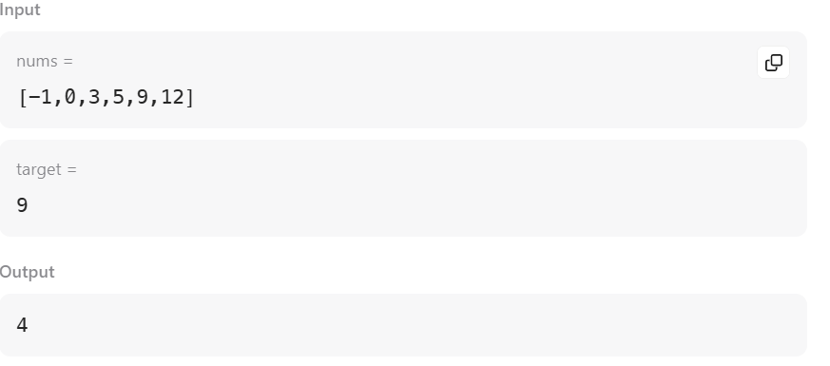

Case 2:
